1. What is the SI unit for measuring volume? ____________________________

2. What is the SI unit for measuring mass? ____________________________

3. What is the SI unit for measuring length? ____________________________

4. How many milligrams are there in 1gram? ____________________________

5. If 1 marble has a mass of 1 gram, then

100 marbles would have a mass of 1 ________________

1000 marbles would have a mass of 1 ________________

6. Which prefix means one hundredth? ____________ one thousandth? ___________

What is the value of each prefix below?

7. Kilo (K) _________________

8. Hecto (H) _________________

9. Deca (da) _________________

10. deci (d) _________________

11. centi (c) _________________

12. milli (m) _________________

13. Which direction do you move the decimal to convert from centigrams (cg) to the basic unit for mass, grams(g)? ______________________

14. Which direction do you move the decimal to convert from Kiloliters (kL) to centiliters (cL)? ______________________

15. Which direction do you move the decimal to convert from millimeters (mm) to basic unit for length, meters (m)? ______________________

**Convert each quantity below.** *Scratch Paper Area*

16) 50.2 cm = _______________ m

17) 89 m = ________________ Km

18) 2.16 L = ________________ mL

19) 0.000827 Kg = ________________ mg

**Tell what each tool below is used to measure.**

20. 21. 22.

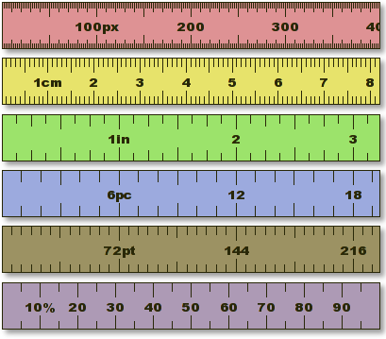 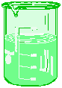 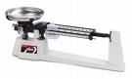

______________________ ___________________ ___________________

**Name an object that you would measure with each tool above.**

______________________ ___________________ ___________________

23. What is the difference between Qualitative data and Quantitative data?

_____________________________________________________________________

**Tell whether the data below is an example of Qualitative (QL) or Quantitative (QN) data.**

24. The light is yellow. __________

25. The length of the desk is 1.2 meters. _____________

26. The ice is cold. _______________

**Tell whether the hypothesis is Testable (T) or Not testable (N).**

______ 27. Motorcycles get more miles per gallon of gas than trucks do.

______ 28. GE light bulbs last longer than generic light bulbs.

______ 29. Blueberry muffins taste the best.

30. What mass does the triple beam balance measure to the nearest tenth (0.1) g?

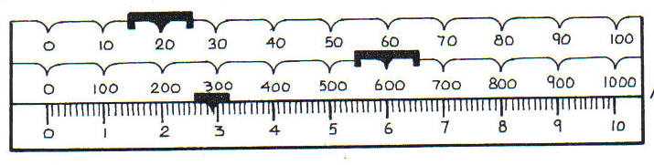

__________g

31. 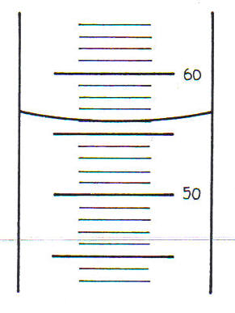What volume does the graduated cylinder measure?

` ___________ ml

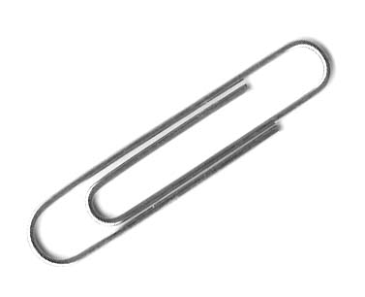

32.What length does the ruler measure the paperclip to the nearest tenth (0.1) cm?

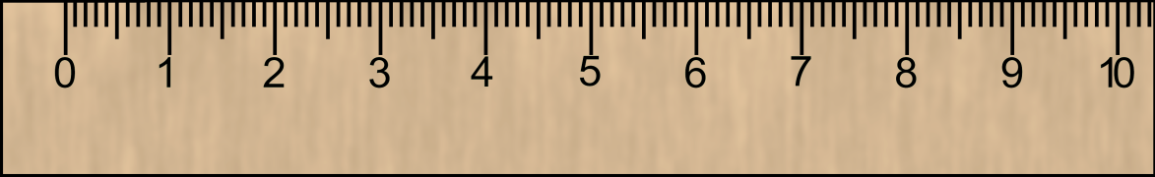 ___________cm

What length does the ruler measure the paperclip to the nearest mm?

___________ mm

33. Below is a hypothesis for an experiment. What is the *dependent* variable and the *independent* variable for this experiment?

*Hypothesis: The* GE light bulbs last longer than generic light bulbs*.*

Independent Variable (IV) ________________________________________

Dependent Variable (DV) _________________________________________

**A scientist wants to know if the paper towels from home are more absorbent than the paper towels from work. What is each step of the scientific method of this experiment?**

34. Make a guess that the paper towels from home are more absorbent. ______________

35. Design an experiment to use both types of paper towels to soak up water.__________

36. Measure the volume of water each type of paper towel held. _____________________

37. From the data, decide which paper towel was more absorbent. ___________________

38. Compare the results to their hypothesis to see if they were right. _________________

39. The _____________ of the line below would best be measured in which ***unit***? _______

**_____**

40. The ______________ of the drink below would best be measured in which ***unit***? _____

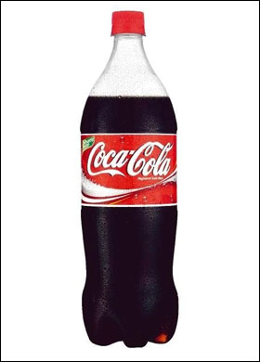

41. The ___________ of a marble would best be measured in which ***unit***? ________

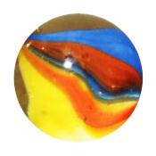

***Convert these using your metric conversion chart.***

1. 756 m=____________________ Km
2. .000235 Kg=________________ mg
3. 2.45 L=___________________ mL
4. 755.2 cm=_________________m
5. 987 Dg=_________________dg
6. .0265 HL=_________________dm
7. 59 m=__________________mm

***Use dimensional analysis convert numbers 8-15.(Circle your answer and use the correct unit)***

1. 5.9 Gallons to Liters (1 gal = 3.79 L)
2. 33 inches to centimeters (2.54 cm = 1 in)
3. 9.2 hours to minutes (1 hr = 60 min)
4. 4 pounds to kilograms (1 Kg =2.2 lbs)
5. 55 minutes to seconds (1 min. = 60 sec)
6. 2.3 miles to feet (1 mile = 5,280 ft)
7. 5.5 miles to yards (1 mile = 1760 yds)
8. 3.6 hours to seconds (1 hr = 60 min; 1 min = 60 sec)