**1st Semester Physical Science Study Guide**

1. What is the SI unit for measuring volume? ____________________________

2. What is the SI unit for measuring mass? ____________________________

3. What is the SI unit for measuring length? ____________________________

4. How many milligrams are there in 1gram? ____________________________

5. If 1 marble has a mass of 1 gram, then

100 marbles would have a mass of 1 ________________

1000 marbles would have a mass of 1 ________________

**Convert each quantity below.** *Scratch Paper Area*

58.2 cm = _______________ m

78 m = ________________ Km

5.26 L = ________________ mL

0.000727 Kg = ________________ mg

**Tell what each tool below is used to measure.**

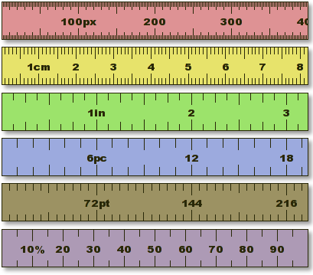 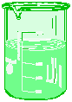 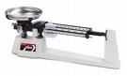

______________________ ___________________ _______________

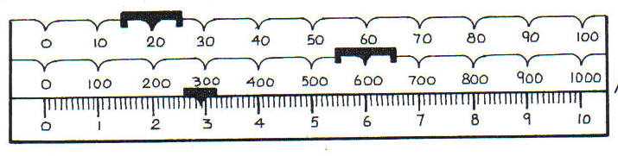What mass does the triple beam balance measure to the nearest tenth (0.1) g? __________g

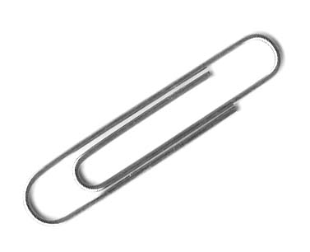__________g

What length does the ruler measure the paperclip to the nearest tenth (0.1) cm? ________________cm

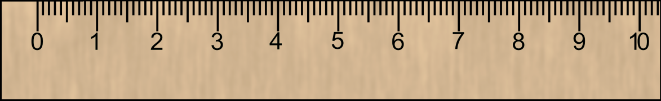

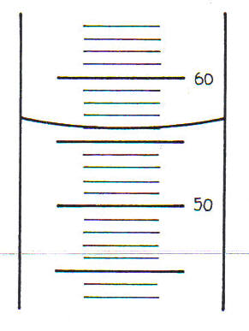

What volume does the graduated cylinder measure? ___________ml

*Hypothesis: The* GE light bulbs last longer than generic light bulbs*.*

Independent Variable (IV) ________________________________________

Dependent Variable (DV) _________________________________________

What is the charge and location of the following subatomic particles in the atom?

Protons________________________________

Neutrons_______________________________

Electrons_______________________________

What are the outermost electrons of an atom called? ___________________ ____________________

Mendeleev published the first periodic table. He arranged all the known elements in order of increasing ___________ _______

Define these terms which are used to describe metals:

Ductile = _______________________________________________________________________

Malleable = _____________________________________________________________________

Luster = ________________________________________________________________________

**Label the periodic table outline below.**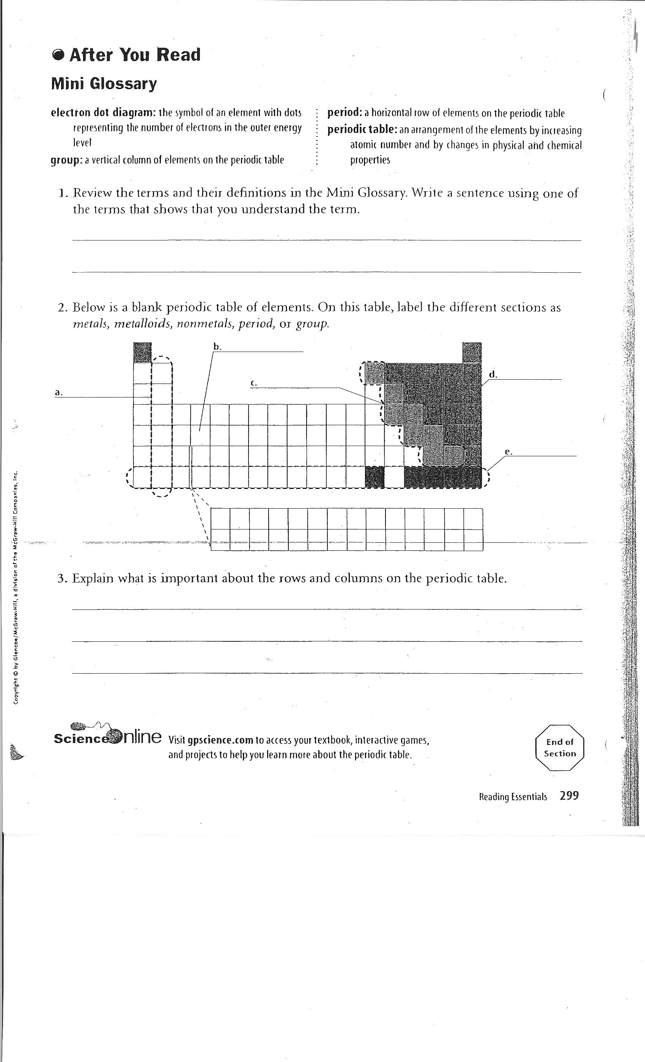

What are the names of the following families on the periodic table?

* 1. Group 1: ____________________________________________
  2. Group 2: ____________________________________________
  3. Group 17: ___________________________________________
  4. Group 18: ___________________________________________

Which group from would be the least reactive, or most stable, group? ________________________

Why? ______________________________________________________________________________

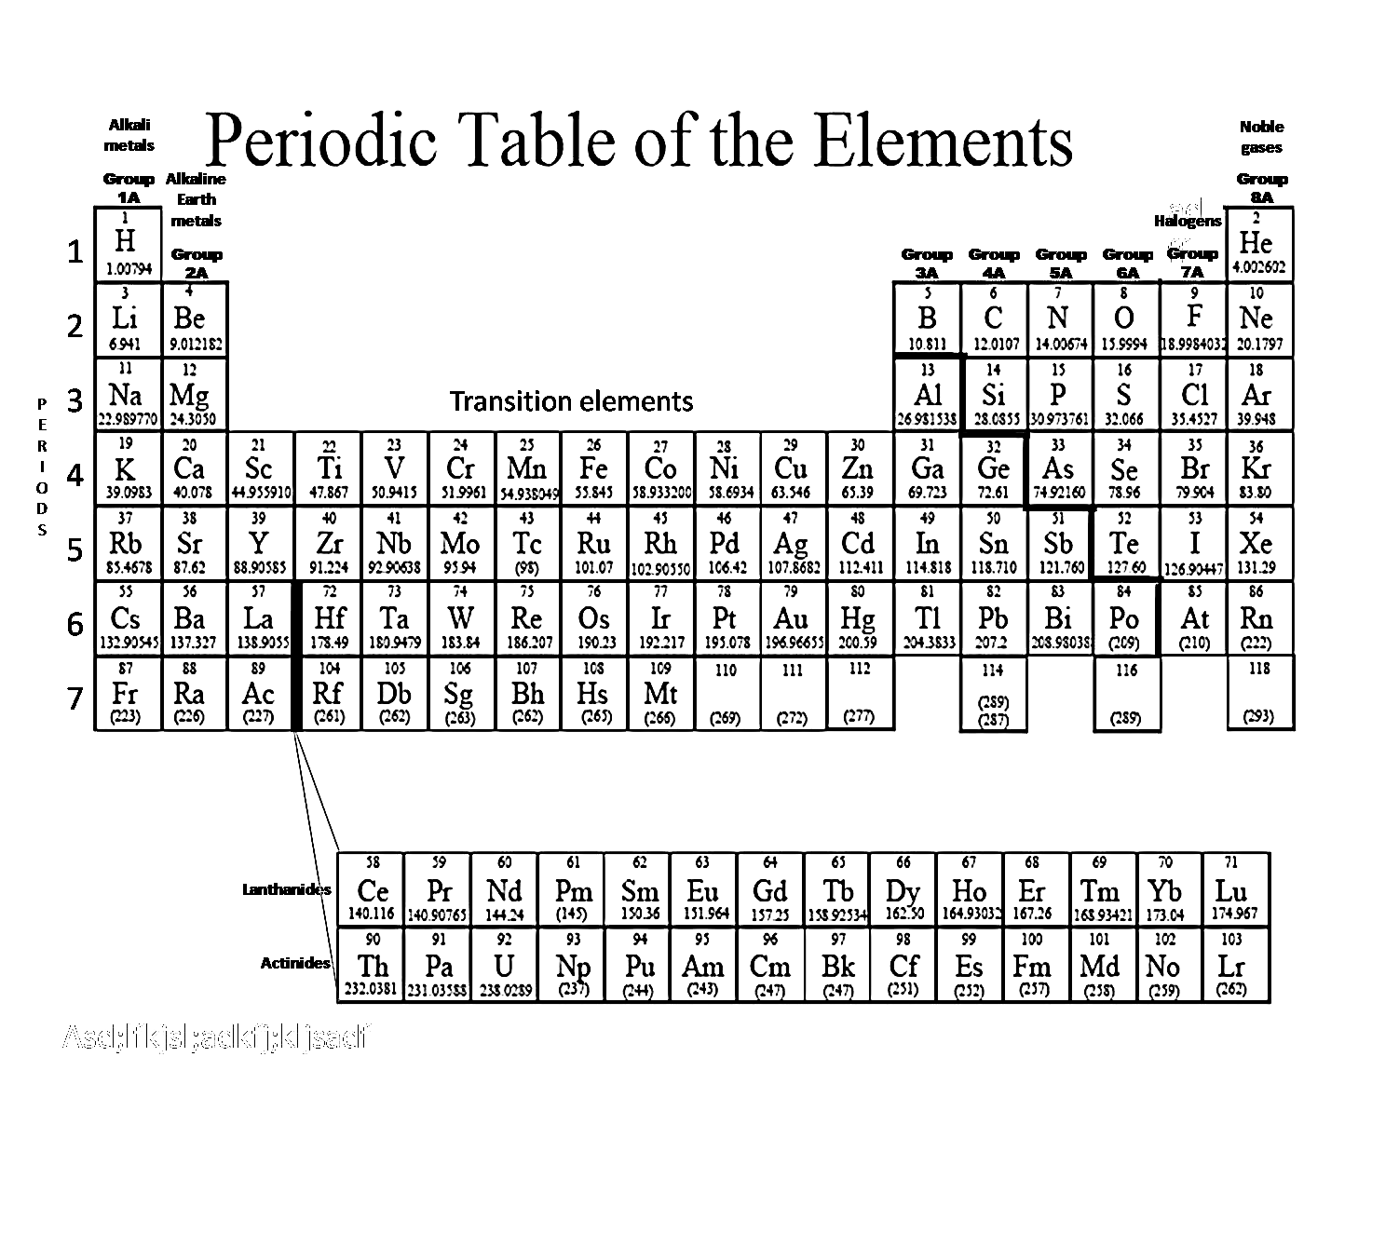

1. Which element has atomic number 12? _______
2. Which element has atomic number 56? _______

Write the formula for calculating the number of neutrons in an atom.

___________ **-** ___________ **=** __________

1. How many neutrons does Be have? _______
2. How many electrons does Ca have? _______
3. How many electrons does Sr have? _______
4. Which element would be the most reactive? _______
5. Which element would have the fewest electron shells? _______
6. Which element has the most subatomic particles? ________

Define the following:

1. **Protons:**
2. **Electrons:**
3. **Neutrons:**
4. **Ions:**
5. **Mass Number:**
6. **Atomic Number:**
7. **Valence Electrons:**
8. **Metalloids:**
9. **Transition Metals:**

Find the element **Chlorine** **(Cl)** on the periodic table.

Atomic # ___________ # of protons __________

# of electrons __________ # of energy levels (period #)_________

**Draw the Bohr’s Model of electrons**

# of valence electrons (group?)_______

Draw the Lewis Electron Dot Diagram

Atomic Mass _________

# of neutrons _________

What is the chemical formula for water? _________________

The freezing point of water is ___________.

The boiling point of water is ____________.

**Properties**

**physical properties chemical property physical changes chemical change phase changes**

1. _____________ _____________ are a form of physical change because the substance stays the same.
2. Flammability, the ability to burn, is an example of a _________________ _________________.
3. Cutting paper and phase changes are examples of _________________ ___________________.
4. Burning white paper to become black ashes is a type of _________________ _______________.
5. _______________ _________________ include color, odor, and shape.
   1. **Describe the following properties as: Physical or Chemical**

Ability to burn: _____________________ ability to react: ______________________

Color, shape or size: _____________________ density: ________________________

* 1. **Describe the following changes as: Physical or Chemical**

Cut paper into two pieces: _________________ Iron rusts: _______________________

Melt ice: _____________________ Wood burns: ______________________

**BaCl2 + Na2SO4** 🡪 **BaSO4 + 2NaCl**

Identify the *reactants* in this chemical equation: __________________________

Identify the *products* in this chemical equation: __________________________

In which type of bond are electrons shared? __________________________

In which type of bond are electrons transferred? __________________________

The part of the solution that gets dissolved: _______________

The part of the solution that does the dissolving: _________________

Which part is usually the greatest in a solution: _________________

In a solution of Kool-aid drink, sugar and Kool-aid are the _______________ and the water is the _________________.

Balance the following equations:

**____Mg +** ____ **O2 →** _____ **MgO**

**____Fe + ____O2 → _____Fe2O3**

**____Al + ____ HCl → ____AlCl3 + ____H2**

Using Oxidation numbers, write the product for the following reactions. (criss cross method)

Ca + 0 **→**  _______________

Al + Br **→**  _____________

Na + S **→** ___________

Write the name for the compounds LiBr. _____________________, NaOH___________________________

*Identify each equation as one of 4 types of chemical reactions.*

1. 2HCl + Zn 🡪 ZnCl2 + H2 _________________________________________
2. 2H2O2 🡪 2H2O + O2 _________________________________________
3. BaCl2 + Na2SO4 🡪 BaSO4 + 2NaCl _________________________________
4. 2Na + Cl2 🡪 2NaCl _________________________________________

**Complete the Table**

|  |  |  |  |  |  |
| --- | --- | --- | --- | --- | --- |
| **Isotope/Ion Name** | **atomic #** | **mass #** | **# of protons** | **# of neutrons** | **# of electrons** |
| Lithium-7 | 3 |  |  |  |  |
| Boron-11 |  |  |  |  | 5 |
| Neon-20 |  |  | 10 |  |  |
| Mg +2 |  |  | 12 | 12 |  |

*Use the pH scale below to answer the following questions:*

What is the strongest acid on the scale? ______________

What is the strongest base on the scale? _____________

Which substance is neutral? ______________________

Write a neutralization reaction between hydrochloric acid (HCl) and sodium hydroxide (NaOH).

Which food/drink has a pH closest to the pH of stomach acid? _____________________________________

If you are told to clean the oven, would you use an acid or a base? ________________________________

Bodily fluids such as urine, saliva, and blood are close to being _______________________________.

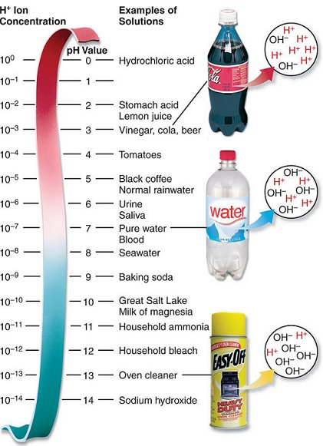*Use the pH scale on the left to answer questions 8-11.*

_______8. Which of the following substances is the strongest acid on the scale?

1. Tomatoes
2. Sea water
3. Lemon juice

_______9. Which of the following substances is the strongest base on the scale?

1. Oven cleaner
2. Baking soda
3. Bleach

_______ 10. Which has more OH**-** ions?

1. Coke
2. Water
3. Easy-Off

_______ 11. If you needed to neutralize a reaction of Hydrochloric Acid (HCl), which substance would work best?

1. Seawater
2. Sodium Hydroxide
3. Stomach Acid

Identify the acid & base as well as the salt and water in the Acid/Base neutralization reaction below.

HCl + KOH 🡪 KCl + H2O

Complete the reaction below:

HI + NaOH 🡪

HBr + LiOH 🡪

_____________________ paper is a pH indicator we have talked about in class.

Red litmus paper will turn _________________ in the presence of a ________________.

Blue litmus paper will turn _________________ in the presence of a ________________.

_____________________ paper is a pH indicator we have used in class.

Red litmus paper will turn _________________ in the presence of a ________________.

Blue litmus paper will turn _________________ in the presence of a ________________.

**pH Scale**

Acidic Neutral Basic

* + 1. 1 2 3 4 5 6 **7** 8 9 10 11 12 13 14

_________ According to the pH scale above, which of the following pH measurements is basic?

1. 7.0
2. 3.2
3. 10.5

________ In a neutralization reaction, an acid and a base combine to form _____.

1. water
2. a salt
3. both a & b

________ Which of the following is an acid?

1. lemon juice
2. water
3. soap

________ Which of the following is an base?

1. lemon juice
2. water
3. soap

According to the pH scale above, which pH measurements are Basic? ________________________

Neutral? __________________________ Acidic? ___________________________

What type of substances are typically acids? __________________________________________

What types of substances are typically bases? ________________________________________