***Motion***

|  |
| --- |
| 1. The formula to calculate velocity: |
| 1. The formula to calculate acceleration: |

1. Negative acceleration means that the change in velocity has ____________________.
2. Label these as acceleration or velocity?
   1. A car traveling east 70 mi/hr. C. A train decreasing speed 50 m/s/s.
   2. A car speeding up from 33 km/hr to 42 km/hr. D. A bus driving north at 30 m/s.

C:\Users\sstanley\AppData\Local\Microsoft\Windows\Temporary Internet Files\Content.IE5\3N7VD1PN\MCj00787150000[1].wmf

***Use the table to answer questions #5-6.***

|  |  |  |  |  |
| --- | --- | --- | --- | --- |
| **Distance** | **5m** | **10m** | **15m** | **20m** |
| **Runner #1 Time** | 1.7 s | 2.5 s | 3.1 s | 3.9 s |
| **Runner #2 Time** | 1.1 s | 2.2 s | 3.3 s | 4.5 s |

1. Using the data table above, which runner had the fastest time in the first 5m? ____________

Which runner had the fastest time in the last 5m? ____________

1. Which runner won the race? ________________

|  |
| --- |
| 1. A sprinter accelerates from 0 m/s to 4 m/s in 8 seconds. Calculate her acceleration? a=vf-vi   t |

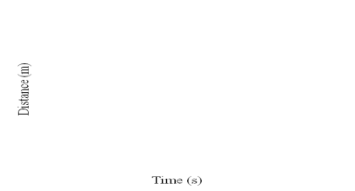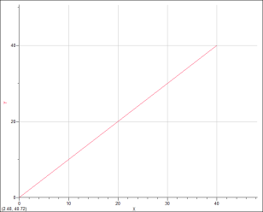

1. Circle which words are true about this graph of velocity.

zero increasing

constant decreasing

10

9

8

7

6

5

4

3

2

1

0 1 2 3 4 5 6 7 8 9 10

Distance (m)

Time (s)

changing

|  |
| --- |
| 1. Calculate the slope of the bubble in this velocity tube on the right.   The slope of the line tells the ____________________ velocity. |

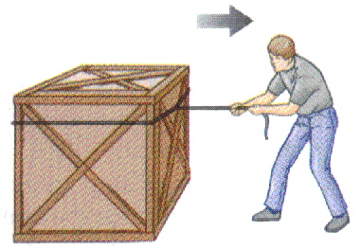***Forces***

1. A push or a pull is called a ________________.
2. Which of Newton’s laws of motion says “For every action there is an equal and opposite reaction.”

_____________________________________________________

1. Unbalanced forces result in ________________.

|  |
| --- |
| 1. According to Newton’s 2nd Law of Motion (**F = m x a**) how much **force** is exerted by a 2000kg mass at an acceleration of 45 m/s2. |

1. Complete the rule: “The _______________ mass, the ________________ momentum.”
2. Two trucks have a collision. Truck A has a mass of 2000 kg and was going 40 mph. Truck B

has a mass of 1500 kg and was going 25 mph. Circle the truck that had more momentum?

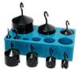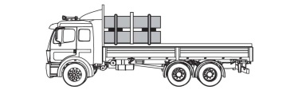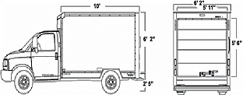

**Truck A Truck B**

1. The tool that measures the force of gravity on an object is called a ____________ _____________.
2. If you are riding on a school bus, your frame of reference is the ______________.
3. Sliding friction is in the _______________________ direction as the motion of a moving object.

***Energy***

1. Kinetic energy is the Energy of ________________________.
2. Potential energy is ________________ energy.
3. At the top of a hill the roller coaster car will have the most __________________ energy.

At the bottom of a hill the roller coaster car will have the most __________________ energy.

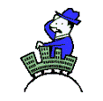

***Heat***

1. C:\Users\sstanley\AppData\Local\Microsoft\Windows\Temporary Internet Files\Content.IE5\1X3X4SID\MCj04136240000[1].wmf ________________________ is the measure of the average kinetic energy of the particles in a substance.
2. Higher temperatures indicate _____________ motion of molecules.
3. Heat transfer by conduction requires ___________________________ .

C:\Users\sstanley\AppData\Local\Microsoft\Windows\Temporary Internet Files\Content.IE5\CYPM84D4\MCj03974920000[1].wmf

1. The boiling point of water is _________ oC.
2. A substance that easily lets heat transfer is a __________________.

A substance that does not let heat transfer is a _______________________.

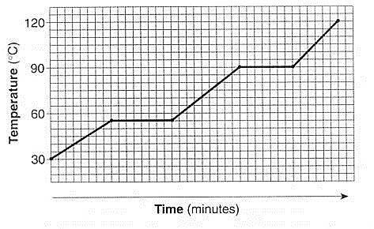

1. According to the heating curve above, what is the melting point of this substance? ______ oC
2. Heat transfer, like everything in science moves from ____________ to _____________.
3. 3 materials (Type A, B, &C) were filled with cold water. According to the graph, which material is the best insulator? __________

|  |
| --- |
| 1. How much heat in joules is required to increase the temperature of 100 g of water by 15⁰C? (specific heat of water (c) = 4.18 J/g⁰C) **Q = mcT** |

***Electricity***

1. ________________________ is the measure of the flow of electrons.

1. Negatively charged subatomic particles are called _____________________.

1. A device that you can reset that protects a circuit from becoming overloaded is a

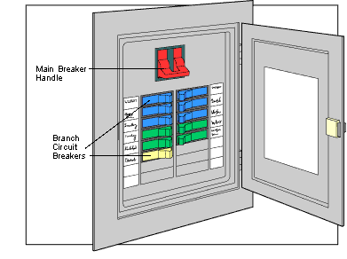

_________________ _______________________.

1. Electricity can flow in a _______________________ circuit.

1. The unit of measurement for current is _____________________.

|  |
| --- |
| 1. A battery with a voltage (E) of 9volts is hooked up to a light bulb with a resistance (R) of 3 ohms. How much current (I) in amps passes through the light? **I = E/R** |

1. If resistance increases, then current __________________________.
2. According this diagram, light B cannot be on because

A B

3 

**+**

**-**

3

_________________________________________

_________________________________________

1. 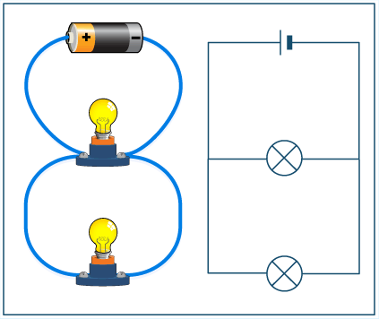 An electric current flowing around an iron rod that acts like a magnet is called a(n)

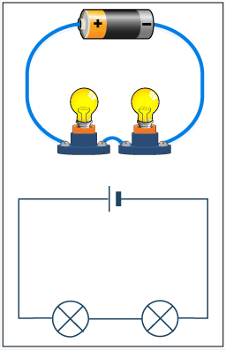______________________________.

1. In a __________________________ circuit, if one bulb stops working then all of the other bulbs will not work.
2. In a _____________________________ circuit, one bulb can go out and the other bulbs will still be able to work.
3. Batteries are an example of electrons moving in only one direction. This is referred to as

_______________________ current.

1. Which of the following correctly shows the magnetic field produced by a bar magnet?

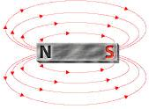



***Waves***

1. The crest of a wave diagram corresponds to the _________________ point of the wave.

1. The distance between the crest of one wave and the crest of the next wave is called its

_____________________________.

1. A wave where the motion of the wave is perpendicular to the direction the wave’s energy is moving is a _______________________________ wave.

|  |
| --- |
| 1. Write the formula for calculating the speed of a sound wave: |
| 1. What is the speed of a wave with a wavelength of 1.8 m and a frequency of 278 hertz? |

***Use the 3 graphs below to answer questions 49-51.***

**A B C**

1. Wavelength: shortest wavelength? ___________ longest wavelength? ___________
2. Amplitude: least amplitude? ___________ greatest amplitude? ___________
3. Frequency: lowest frequency? ___________ highest frequency? ___________

1. The diagram below shows an incident ray on a plane mirror.

Draw a line at the correct angle for the reflected ray?

Red Blue

Green

1. Mixing the primary colors of light, red, blue, and green light, will produce _____________________ light.
2. The colors we see are due to the light waves that are ___________________.
3. Between which two points below is wavelength properly calculated? _____________

B D

A C E G

F

1. Lenses ______________________ light, while mirrors __________________ light.

***Use the 3 graphs below to answer questions 57-58.***

**A B C**

1. Which of the diagrams above illustrates the reflection of a concave mirror? ________
2. Which of the diagrams above illustrates the refraction of a convex lens? _________

concave lens? _________________

|  |
| --- |
| 1. In 1 second four crests of a wave pass a certain point. What is the wave's frequency? |

1. All electromagnetic radiation travels at ___________________________ m/s.